Augusta Uniting Church – Booking Form
68 Blackwood Avenue, Augusta WA 6290
PO Box 753, Margaret River, WA 6285 margsuniting@gmail.com
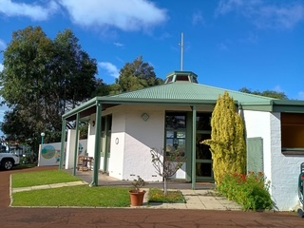
Name:___________________________________________________
Organisation:_____________________________________________
Phone:_________________________Email:______________________________________
Date(s) requested:__________________________________________________________
Start:_________________________Finish:_______________________________________
Expected number of attendees:__________ Admission fee charged:_____________
Indemnity Insurance Number:________________ Amount:________________________
If no insurance Uniting Church Insurance required @ $10 per session; YES NO
Requirement Rate Subtotal
2 hour minimum hire $45 $
Half Day – 4 hours $65 $
Full Day Rate $125 $
Uniting Church Insurance $10 $
_________________________________________________________________________________Total____________________________________________________________ $_______________
Conditions of Use

- A minimum of 24 hrs notice cancellation for a refund.
- Light switches located below the internal main power board in alcove to the left of front door.
- Kitchen has microwave, fridge, urn, crockery and cutlery. Fridge needs to be turned on and off and completion of use. BYO tea/coffee etc.
- Tables and chairs are available for use.
- Alcohol only if approval sought and appropriate regulations met.
- Toilets located in the building. Please advise if supplies need replenishing.
- Please leave the church clean and tidy. Supplies and vacuum in the kitchen. An additional fee of $80 required if further cleaning is needed.
- Please ensure all power is switched off.
- Please return key to the lock box at conclusion after everything has been locked.
- Please keep the driveway to rear house clear and be respectful of neighbours and community garden on the premises.
- Payment details: Augusta UCA BSB 633000 Bendigo Bank acc 210570834
- lock box code will be advised by email on acceptance of booking. Do not share code.
- If you have any queries please contact Mary Elton on 0429797767 or elton5@bigpond.com

